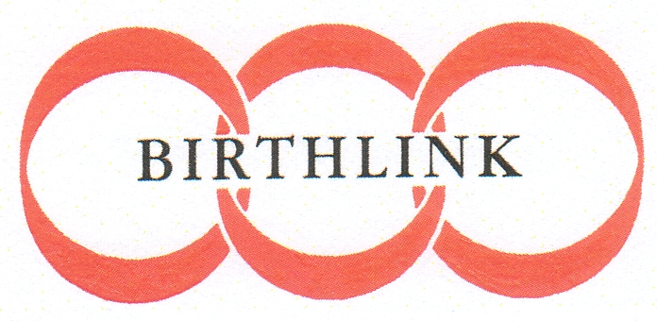
Over a hundred years of connecting people

BECOME A MEMBER

Forename: __________________________ Surname:__________________________

Address: _____________________________________________________________________
________________________________________________________________________

Telephone: __________________________ E-mail:__________________________

I wish to pay my annual membership of £30.00 for the year 2025. | Y |  | N
I enclose a cheque. | £
or
I wish to pay by standing order. | Y |  | N
(If yes, please complete standing order mandate enclosed and send this to your bank. Do not return this to Birthlink)
I also wish to support Birthlink by making regular payments. | Y |  | N
(If yes, please complete standing order mandate enclosed and send this to your bank. Do not return this to Birthlink)
I am a UK taxpayer. I wish all donations I make to Birthlink to be treated | Y |  | N
as Gift Aid Donations.
(If yes, please complete Gift Aid Declaration enclosed, if appropriate.)
I am also willing to support Birthlink in other ways, and I am happy to be | Y |  | N
contacted when required.

Members are admitted to membership in Terms of its Articles of Association. The subscription year runs from 1st April to 31st March.

I confirm that I have read the: Privacy policy - Birthlink

Signature: __________________________ Date: __________________________
Over a hundred years of connecting people

STANDING ORDER MANDATE
(Complete and send to your bank)

Title
Forename
Surname
Address
Postcode
Telephone Number

To:

The Manager
Your Bank Name
Your Bank Address
Your Sort Code
Your Account Number
Please pay the sum of £________ each *calendar month/*annually to the Bank of Scotland, 38 St Andrew’s Square, Edinburgh, EH2 2YR, for the credit of Birthlink, Account Number 00368908, Sort Code 80-41-21, starting on ____________________________________, until further notice.
* Please delete as appropriate.
Please note that this standing order will override all previous arrangements made payable to Birthlink from this account.

Signature: __________________________ Date: __________________________

over a hundred years of connecting people

Charity Gift Aid Declaration – single donation
Boost your donation by 25p of Gift Aid for every £1 you donate.
Gift Aid is reclaimed by the charity from the tax you pay for the current tax year. Your address is needed to identify you as a current UK taxpayer.

In order to Gift Aid your donation you must tick the box below:

I want to Gift Aid my donation of £______________ to Birthlink

I am a UK taxpayer and understand that if I pay less Income Tax and/or Capital Gains Tax than the amount of Gift Aid claimed on all my donations in that tax year it is my responsibility to pay any difference.

My Details:

Title ____________________ First name or initial(s) _______________________________

Surname ___________________________________________________________________

Full Home address _____________________________________________________________________________ _____________________________________________________________________________ _____________________________________________________________________________

Postcode __________________________ Date ____________________________________

Please notify the charity if you:
• want to cancel this declaration,
• change your name or home address,
• no longer pay sufficient tax on your income and/or capital gains.

If you pay Income Tax at the higher or additional rate and want to receive the additional tax relief due to you, you must include all your Gift Aid donations on your Self-Assessment tax return or ask HM Revenue and Customs to adjust your tax code/

Please see our privacy policy at: Privacy policy - Birthlink

